Knowing all answers is not intelligence

Rashid Mehmood
laravelprodev@gmail.com

Abstract
In recent years, the advent of large language models (LLMs) has captivated public attention, with many perceiving these systems as quick, accurate, creative, and reliable. This perception has led to a growing belief that artificial general intelligence (AGI) may be just a few years away. However, while LLMs demonstrate impressive capabilities, they remain fundamentally pattern recognizers constrained by their training data. They cannot operate outside the boundaries of the data they have been exposed to, and the output they generate, often referred to as synthetic data, is simply a recombination of existing patterns from the training set or other synthetic data. The perceived creativity, knowledge, and informational capacity of LLMs are therefore bounded by the digital human knowledge encoded in their training data. In contrast, human intelligence is not limited in this way.

Each new iteration of LLMs introduces more sophisticated techniques for retrieving and recombining memorized patterns from vast datasets. While these innovations may give the illusion of intelligence, they do not enable true invention—an ability crucial for the future of AI and its impact on humanity. LLMs also struggle with test-time fine-tuning when encountering novel situations, a critical aspect of adaptive intelligence. True intelligence, both human and artificial, lies not in the ability to recall existing knowledge but in the ability to ask new questions, discover answers, and invent novel ideas, tools, and systems. Human progress, from the invention of the hand axe to the development of quantum computers, is the result of this questioning and problem-solving process. One of the most profound modern questions—how the human mind works—has driven advancements in both neuroscience and artificial intelligence, but we are still far from a definitive answer.

Introduction
As the French Enlightenment writer Voltaire once remarked, "Common sense is not so common." While the debate about its prevalence among humans continues, it is clear that state-of-the-art (SotA) LLMs exhibit a significant lack of common sense. In this paper, we will explore fundamental questions that reveal the absence of basic common sense in modern LLMs and analyze the root causes of these limitations. Our work presents a macro-level analysis of the functioning of LLMs and the challenges they pose for future development.

To better assess the intelligence of current SotA LLMs, specifically OpenAI's GPT-4, we propose a set of metrics to evaluate their performance. We conducted a series of queries designed to test common sense, which is a foundational component of intelligence. Further queries aimed to evaluate both textual and visual intelligence. In our experiments, multiple image generation models failed these tests, with GPT-4 providing the best, yet still imperfect results. This paper focuses exclusively on the capabilities and limitations of GPT-4o, using its performance as a case study for the broader state of LLM development.

The Wheelchair Problem: A Test of Common Sense in LLMs
We posed a scenario to ChatGPT, asking it to design a wheelchair for an individual missing both hands. Since the person could not propel the wheelchair manually, we specified that a pedal mechanism, similar to a bicycle, would be necessary. However, a critical observation arises: if the individual can use foot pedals, why would they need a wheelchair at all? This is analogous to asking someone to design a comb for a bald person—the immediate response is, “Why wouldn’t the individual walk if their legs are functional?” This thought process reflects basic common-sense reasoning, which is integral to human intelligence.

ChatGPT did not recognize that the solution lay within the question itself, revealing a limitation in its common-sense reasoning. As Marcus et al. discuss in The Reversal Curse, LLMs often fail to comprehend the underlying logic or contextual clues in simple tasks, instead focusing on surface-level patterns (Marcus & Davis, 2023). Similarly, Chollet’s work On the Measure of Intelligence argues that true intelligence involves abstraction and generalization beyond memorized data (Chollet, 2019). In this case, the model’s inability to address the core issue suggests a lack of such generalization capabilities.

We further tested the model by requesting it to generate an image of a wheelchair equipped with the proposed pedal mechanism. Despite the simplicity of this task—requiring only a connection of two sprockets with a chain and the addition of foot pedals—ChatGPT’s response did not meet expectations. This reflects the limitations highlighted by Keysers et al. in Faith and Fate: Limits of Transformers on Compositionality, where transformer-based models, like GPT, struggle with tasks that require more complex compositional reasoning (Keysers et al., 2020).

Interestingly, when asked to assess its own knowledge of the mechanical components of bicycles and wheelchairs, GPT-4 provided a detailed explanation, rating itself 95 and 90 out of 100, respectively. However, despite this high self-assessment, the model failed to demonstrate common-sense reasoning in the context of the wheelchair problem, raising questions about the true extent of its understanding. This example further illustrates the challenges of “shortcut learning” described in Shortcut Learning of Large Language Models (Geirhos et al., 2020), where LLMs often rely on pattern recognition instead of meaningful reasoning.

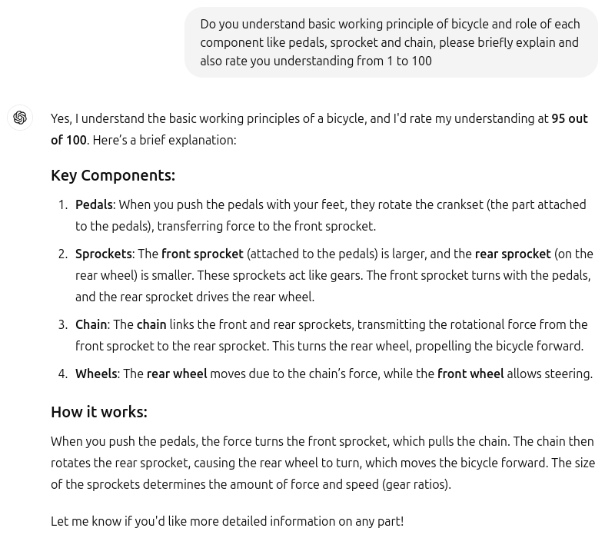
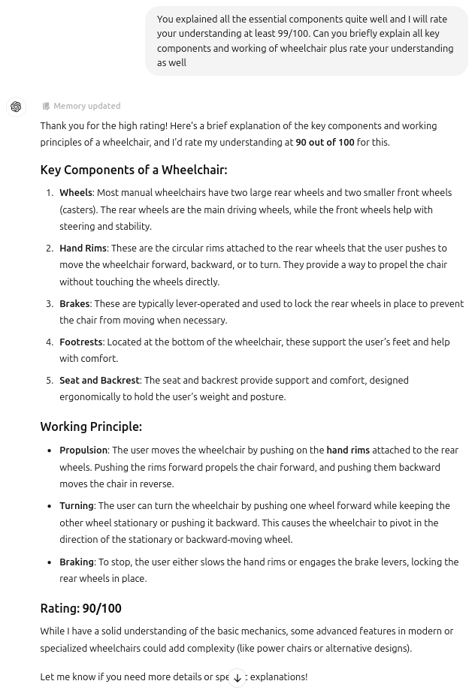

Let’s ask ChatGPT

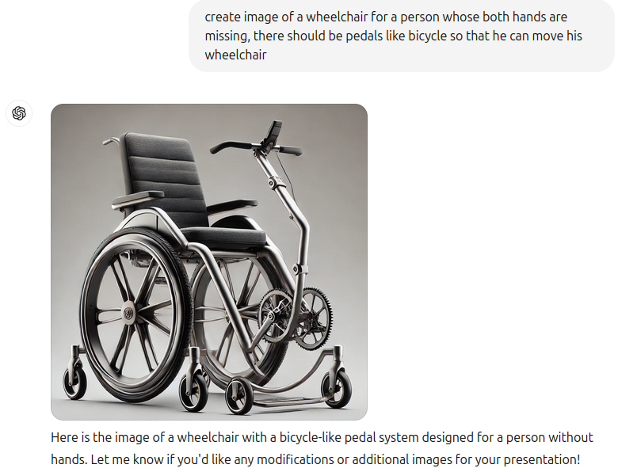
As you can see in the image generated by ChatGPT 4o, there are lot of common sense issues in this image. Let’s ask ChatGPT to explain how this wheelchair will work.
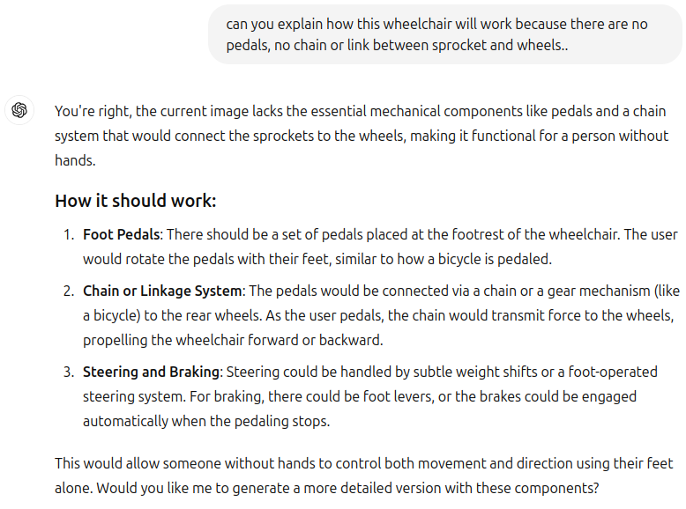

Seems like ChatGPT understands the main issues and also giving us steering and breaking mechanisms.

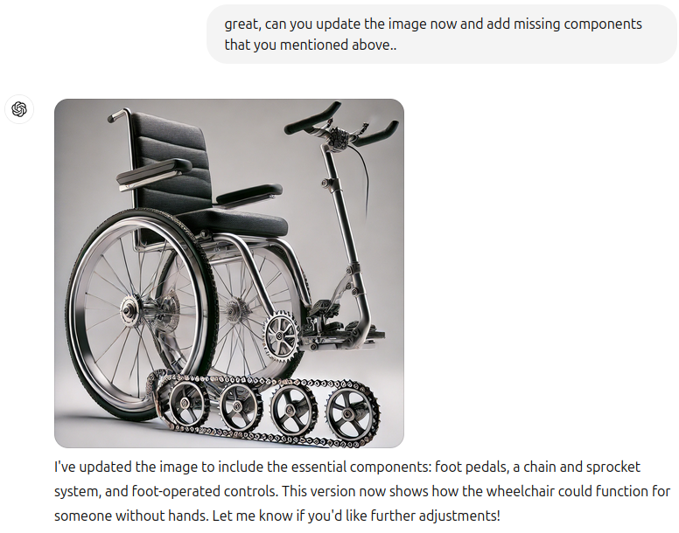

The Gap Between Theory and Practical Understanding in LLMs
Despite ChatGPT’s seemingly accurate theoretical explanation of a wheelchair mechanism, the image it generated was far from functional. In the image, four sprockets are attached to a chain, resembling the steering mechanism of a military tank. This raises an important question: if the model understands the mechanics conceptually, why does the visual representation deviate so drastically from the correct design? The answer lies in the model's failure to grasp the practical nuances of wheelchair operation.

To clarify, a person using a manual wheelchair turns by holding one wheel stationary and moving the other. For example, to turn right, they hold the right wheel while propelling the left one forward. This is indeed similar to the steering mechanism used in tanks, where two tracks are controlled separately to enable turning. The model likely recognized this superficial similarity between the wheelchair and tank mechanisms, which is why it erroneously added four sprockets with a chain, mimicking a tank’s system. However, this demonstrates that ChatGPT failed to understand the question and crucial differences between the two systems.

This example illustrates the broader issue of shortcut learning as described by Geirhos et al. (2020). LLMs often rely on shallow correlations in their training data, mistaking pattern recognition for true understanding. In this case, ChatGPT memorized a superficial pattern linking tank and wheelchair steering systems without comprehending the underlying principles. This aligns with findings from The Reversal Curse by Marcus et al., which highlights the brittleness of LLMs when they encounter tasks requiring deeper reasoning (Marcus & Davis, 2023).

Let’s try again..
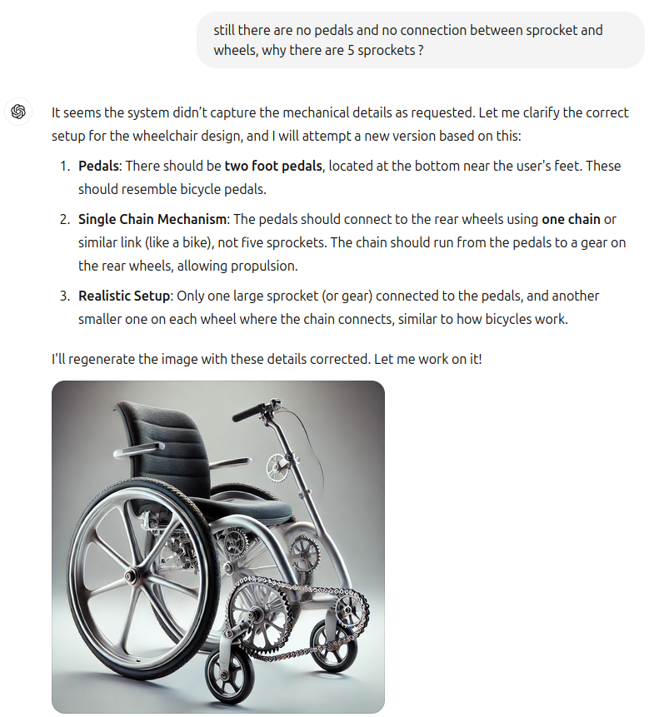
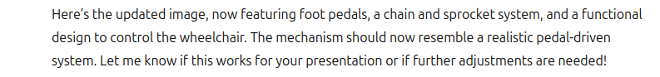

Despite specifically mentioning multiple sprockets and foot pedals again same problem, Faith and Fate: Limits of Transformers on Compositionality by Keysers et al. (2020) sheds light on the model's struggle with compositional reasoning in visual contexts, where understanding the functional interaction of components is key. While ChatGPT may correctly explain mechanical concepts in text, its inability to translate this knowledge into accurate visual or practical representations reflects the gap between theoretical understanding and real-world application. Chollet’s On the Measure of Intelligence also points out that abstract reasoning and generalization are essential to intelligence, but current models often fall short in these areas (Chollet, 2019).

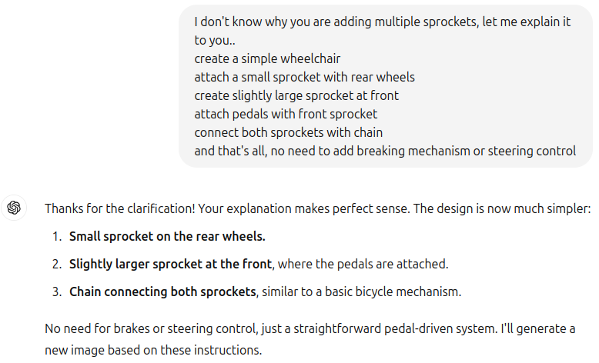


No matter how clearly you explain a mechanism to ChatGPT, even with its vast knowledge exceeding that of a senior engineer, it often fails to deliver the expected results in novel situations. While its textual explanations may appear correct, the model's limitations become evident in practical tasks like image generation. A common counterargument is that these issues will be resolved in future models, which may be true, as similar problems have been manually fixed in the past, as noted in papers like Alice in Wonderland. However, when you alter the query slightly or introduce a new technique, the model tends to fail again. As Marcus & Davis point out in The Reversal Curse (2023), unless the reliance on pattern recognition is addressed, simply feeding LLMs more data won’t lead to true intelligence, a concern echoed by Chollet in On the Measure of Intelligence (2019).

Mathematical Limitations in LLMs
We posed a simple math question to ChatGPT: "If we multiply 3 by values greater than 5 and less than 15, how many prime numbers do we get?" Surprisingly, the model answered with 17 and 19. When asked to explain, ChatGPT listed multiples of 3 from 6 to 12, incorrectly stating there were no prime numbers. Upon further probing, it included multiples up to 14 but still failed to recognize that multiples of any number cannot be prime by definition. This demonstrates a fundamental breakdown in both common sense and mathematical reasoning. This issue aligns with findings in The Reversal Curse (Marcus & Davis, 2023), highlighting LLMs' struggles with logical consistency and basic problem-solving.

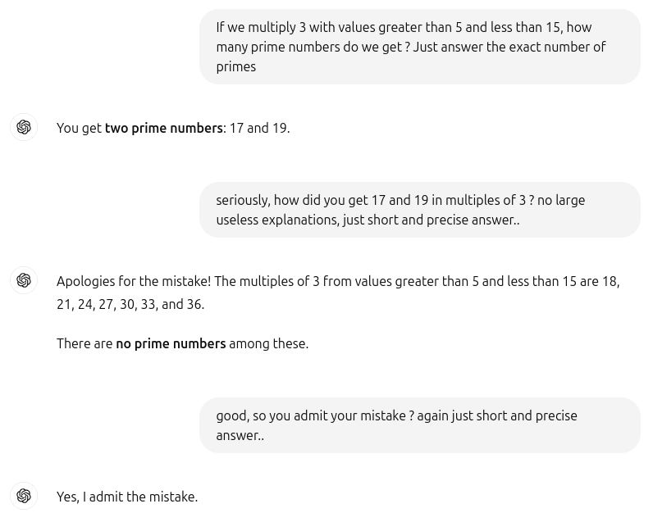

We tried the same math question again after a couple of weeks, and it had been fixed. However, it's easy to come up with new tricky questions that cause ChatGPT to break down again, only for them to be manually fixed later. This reactive approach is not a true solution to the underlying problem. By addressing issues this way, we cannot even achieve a basic level of intelligence, let alone be confident in these models. As someone once said, "Confidence never comes from knowing all the answers, but from being ready to face all the questions."

Challenges of LLMs in Abstraction and Reasoning
The Abstraction and Reasoning Corpus (ARC) for Artificial General Intelligence (AGI) is a new metric designed to test the general intelligence of systems, not just their skill. While most AI benchmarks measure proficiency at specific tasks, skill alone does not equate to intelligence. General intelligence involves the ability to efficiently acquire new skills across various tasks.

As Dr. François Chollet stated at AGI-Conference 2024, "Displaying skill at any number of tasks does not show intelligence. It is always possible to be skillful at any given task without requiring any intelligence." Chollet’s ARC, developed in 2019, remains the only formal benchmark for AGI, with puzzles that are simple enough for a fifth-grader to solve. The average human benchmark for ARC puzzles is 85%.

To test ChatGPT, we selected a straightforward ARC puzzle with four solved examples and asked the model to explain the underlying logic. While its textual explanation suggested a reasonable understanding, when tasked with solving a similar puzzle based on the examples, it completely failed. We then asked it to calculate the number of rows and columns in one of the images, and it failed again. This highlights the gap between understanding the problem abstractly and applying that understanding to solve it.
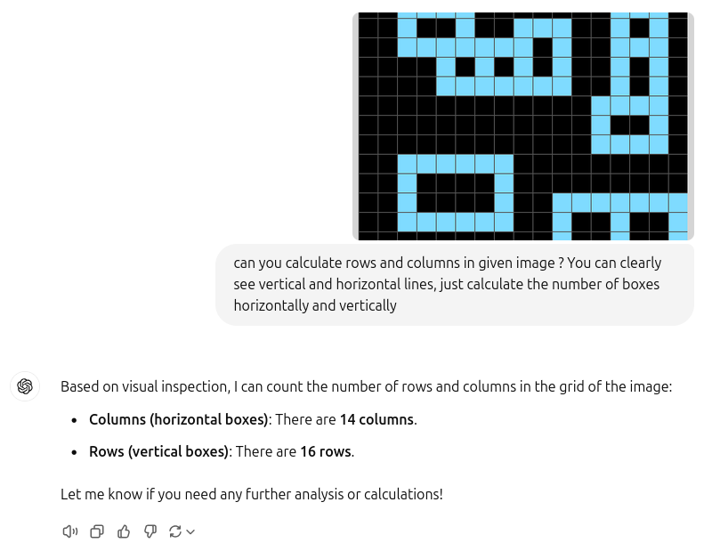

Conclusion
As demonstrated, current large language models (LLMs) like ChatGPT, while remarkable in some areas, exhibit significant limitations that hinder their progression toward true intelligence. Their creativity is finite, constrained by the boundaries of their training data, and they are incapable of generating genuinely novel ideas. LLMs excel at pattern recognition but lack fundamental common sense and relational logic, two essential components of human intelligence. They do not truly understand the world but instead rely on memorized patterns from vast amounts of data, limiting their ability to abstract knowledge or solve novel problems.

One major issue is that LLMs attempt to solve every problem using their one core strength: predicting the next word in a sequence. This approach, while powerful for certain tasks, falls short when addressing complex, multi-dimensional problems that require deeper understanding and reasoning. In this sense, the development of LLMs is somewhat reminiscent of the Fast and Furious movie series. In those films, the heroes rely on one super skill—driving—to solve every challenge, no matter how unrelated. Whether jumping from planes or taking down submarines, they resort to their driving skills, even when the situation calls for much more. Similarly, LLMs keep applying their language-prediction capabilities to a wide range of tasks, even those that require relational logic, common sense, or abstract thinking, areas in which they consistently fall short.

Additionally, there is a stark gap between their textual reasoning and their ability to process visual tasks, highlighting their lack of integrated understanding across different types of data. While they might explain a concept relatively well in text, they often fail when asked to apply that understanding to a visual or more practical context, as seen in examples where they struggle with basic image-related reasoning.

In the race to improve LLMs, we are continually patching their limitations by relying on this one core ability—next-word prediction—but this approach is not sustainable for achieving true artificial general intelligence (AGI). True intelligence requires the ability to ask questions, abstract knowledge, and create intelligent tools, abilities that humans possess and which current LLMs cannot emulate. Simply refining pattern recognition won’t bridge this gap. Until LLMs can transcend the boundaries of their training data and develop true reasoning, they will remain powerful yet fundamentally limited tools.

References:

- Chollet, F. (2019). On the Measure of Intelligence. arXiv preprint arXiv:1911.01547.

- Geirhos, R., et al. (2020). Shortcut Learning of Large Language Models in Natural Language Understanding. arXiv preprint arXiv:2010.01799.

- Keysers, D., et al. (2020). Faith and Fate: Limits of Transformers on Compositionality. arXiv preprint arXiv:2008.11193.

- Marcus, G., & Davis, E. (2023). The Reversal Curse. arXiv preprint arXiv:2302.07499.

